PATHSHALA NEPAL FOUNDATION

PRE-UNI PROGRAM

Baneshwor, Kathmandu



Lab Assessment Report on

Database Management System (Part B)

**Submitted By:** **Submitted To**

Name: Raunak Raj Adhikari Department of Computer Science

Class: 12 PATHSHALA NEPAL FOUNDATION

Group: 1

Date: 2023-08-20

2. Answer the following questions:

1. Introduce DBA and his skills and responsibilities.
2. Introduce database model with its types along with advantages and disadvantages of each of them.
3. Explain briefly about relationship with its types.
4. Introduce and normalization with its advantages along with the brief explanation on 1NF, 2NF and 3NF.
5. Centralized vs Distributed database system.

|  |  |  |
| --- | --- | --- |
| S.N. | Centralized Database System | Distributed database system |
| 1. |  |  |
| 2. |  |  |
| 3. |  |  |
| 4. |  |  |

1. Explain briefly on Data Security.

**Perform the following Task: (P/H)**

1. Create a table named **score** with the following structure inside the database named “school” with reference to the table named “stud_info” you have created in Part A:

Command: Result:

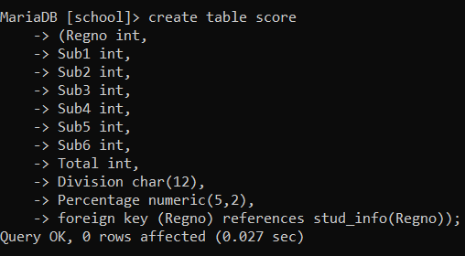 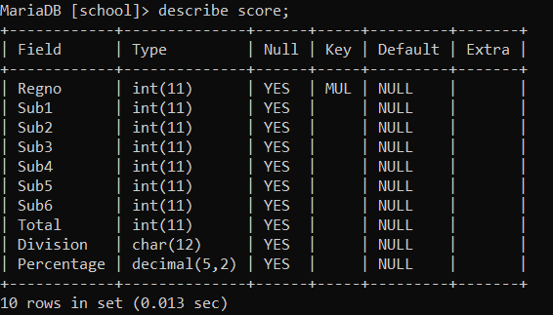

1. Add the following data as follows:

Command:

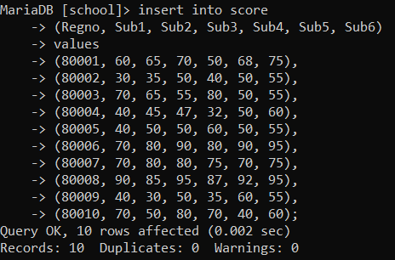

Result:

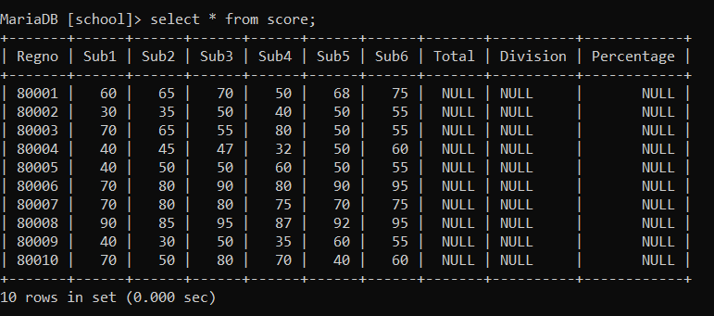

1. Perform the following operations with SQL commands:

⇩

1. Calculate total of all the subjects for all the students:

Command:

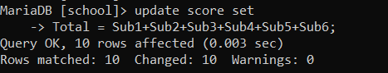

Result:

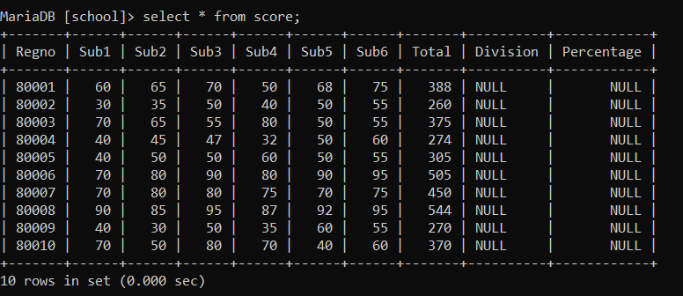

1. Calculate percentage as well.

Command:

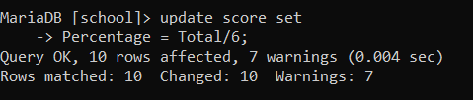

Result:

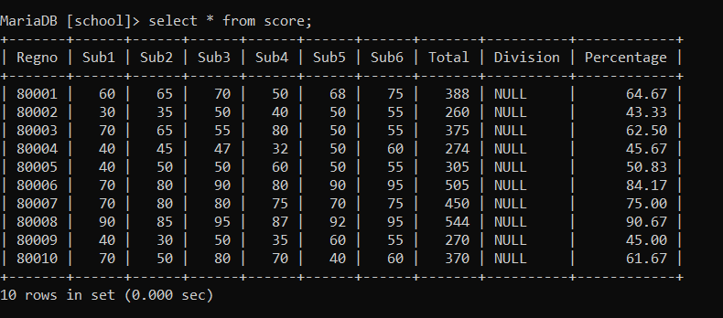

1. Display all regno, name and marks detail along with total and percentage for each students.

Command:

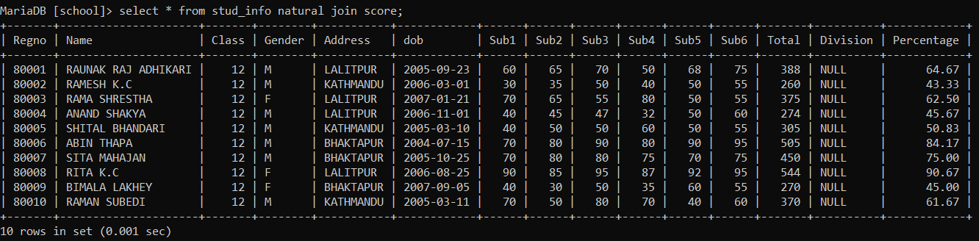

1. Display all the students detail who could pass all the subjects along with regno and name. (hint: pass mark in each subject is 35).

Command:

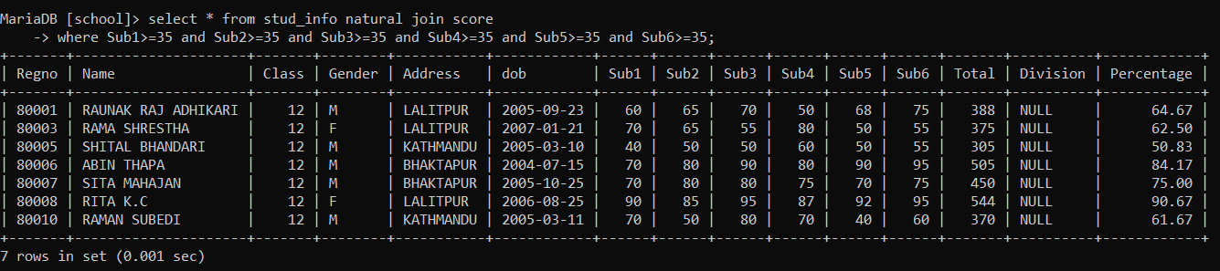

1. Insert a column named result char (4) and calculate result as PASS if the student is able to score 35 or above in all the subjects otherwise update the result as FAIL.

Command:

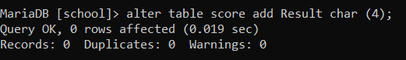

Result:

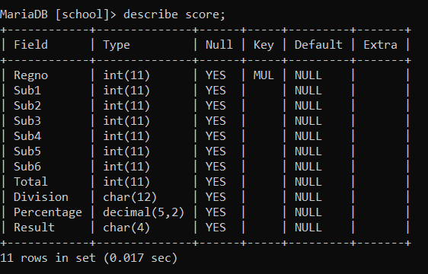

Command:

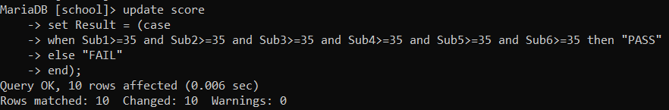

Result:

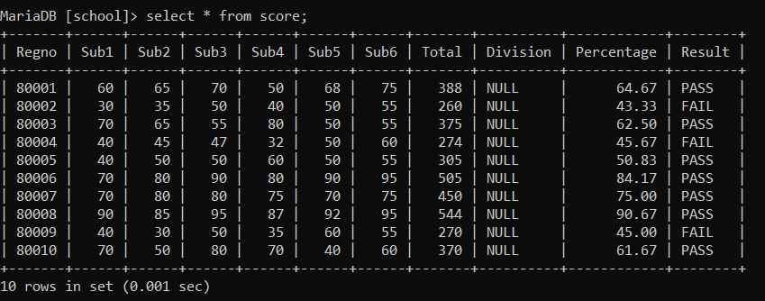

1. Insert on another column named division char (12) and update division following the criteria given below:

* If result is PASS and percentage scored above 75 => distinction
* If result is PASS and percentage score below 75 and above 59.99 => FIRST
* If the result is PASS and percentage scored is below 60 and more or equals to 45 => SECOND
* If the result is PASS and percentage scored is below 45 and more or equals to 35 => THIRD
* Otherwise FAILED.

Command:

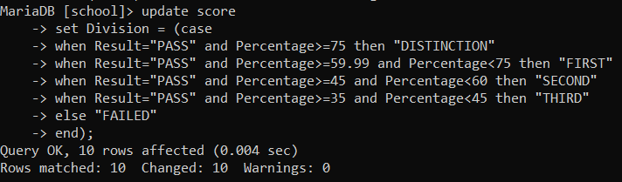

Result:

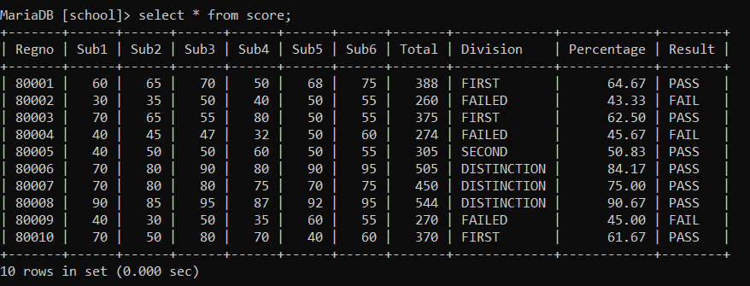

10. Display all regno, name and result with division only.

Command:

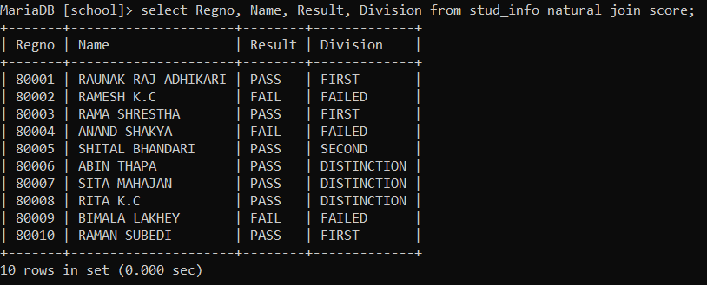

11. Display regno, name, total and percentage along with result and division for the DISTINCTION holder/s.

Command:

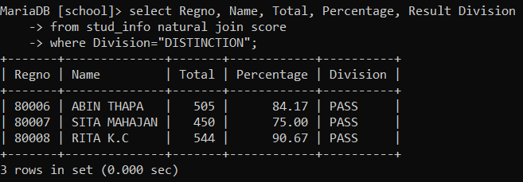

12. Display all the details of students who could not pass the exam.

Command:

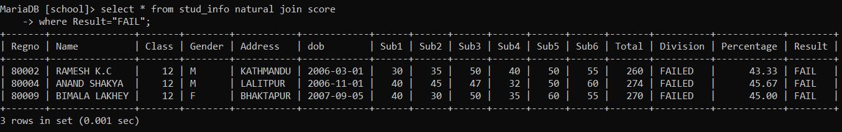

13. Display regno, name and marks detail along with total and percentage for those who could pass the exam with FIRST division.

Command:

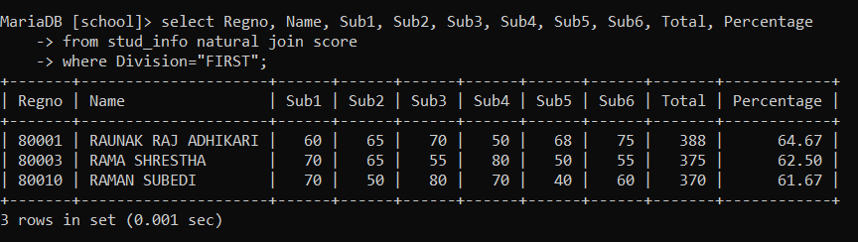

14. Display regno, name and marks detail along with total, percentage, result with division for all the students by the order of result and percentage.

Command:

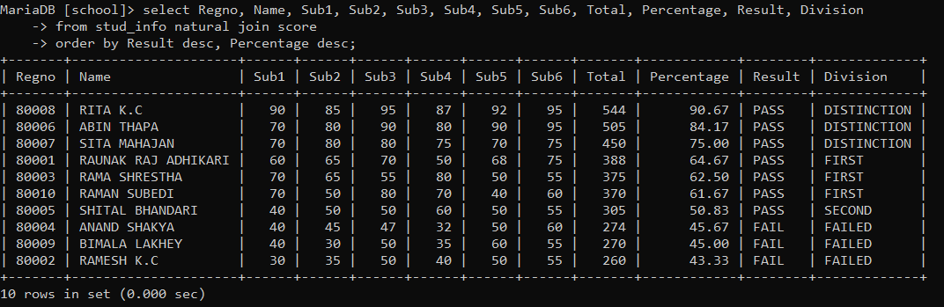

15. Display the regno and name of the student who scored the highest percentage in the exam.

Command:

